**TABLE OF SPECIFICATIONS FOR EXAM QUESTIONS**

**University of Liberal Arts Bangladesh**

**Department: Computer Science and Engineering (CSE)**

**Final Examinations, Semester: Fall 2020**

**Program: B.Sc. in CSE**

**Course Code: CSE404 Course Title: Software Engineering Credit Hr: 3**

**Time: 2 Hours Total Marks: 25**

**Name & Designation of the Examiner: Satyaki Das, Lecturer**

**Learning Outcomes (LO):**

|  |
| --- |
| 1. **Describe** the objective of Software Engineering |
| 1. **Explain** terms related to important software engineering methods, process models, SRS, project management, testing. |
| 1. **Understand** a practical problem, **apply** software engineering principles and techniques to design a software to solve the problem. |
| 1. **Identify** product-related relevant information from Client’s input and **propose** solutions to solve the problems |
| 1. **Integrate** with a team and be willing to resolve conflicts. |
| 1. Learn to clearly communicate to **point out** ideas and concerns |

***Levels in Bloom’s Cognitive Domain:***

***C1: Remember C2: Understand C3: Apply C4: Analyze C5: Evaluate C6: Create***

|  |  |  |  |  |  |  |  |
| --- | --- | --- | --- | --- | --- | --- | --- |
| **Question No.** | **Learning Outcomes (CO)** | **Level in Bloom’s Cognitive Domain along with Allocation of Marks** | | | | | |
|  |  | **C1** | **C2** | **C3** | **C4** | **C5** | **C6** |
| 1 | 1 |  | 5 |  | 5 |  |  |
| 2 | 4 |  |  | 4 |  |  |  |
| 3 | 2 |  | 4 |  |  |  |  |
| 4 | 3 |  |  | 7 |  |  |  |
| **Total Allocation of Marks** | **25** |  | 9 | 11 | 5 |  |  |
|  |  |  |  |  |  |  |  |
| **Question No.** |  | **Learning Outcome** | | | | | |
|  |  | **CO1** | **CO2** | **CO3** | **CO4** | **CO5** | **CO6** |
| 1 |  | 10 |  |  |  |  |  |
| 2 |  |  |  |  | 4 |  |  |
| 3 |  |  | 4 |  |  |  |  |
| 4 |  |  |  | 7 |  |  |  |
| **Total Allocation of Marks** | **25** | 10 | 4 | 7 | 4 |  |  |

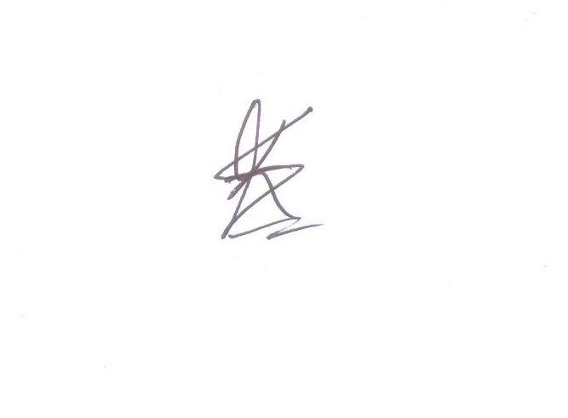

**Signature of the Examiner Date: 12.01.2021**

**INSTRUCTIONS FOR THE FINAL EXAM  
PLEASE CAREFULLY READ THE FOLLOWING INSTRUCTIONS.**  
  
**During the Exam**

1. This is an “open note” exam that allows the students to use any materials handed out in the class, your notes from the lectures, and any other resource that I have already shared with you on Google Classroom.
2. The duration of the exam is 1 Hour 45 minutes and an additional 15 minutes is allotted for answer submission.
3. Show/present all the necessary steps/justifications to derive your answer, where applicable.
4. Showing or discussing anything related to the questions with anyone is prohibited. Hence, usage of any online and offline messaging platforms and external/cloud storage are also strictly prohibited. Further, online searches for preparing your answer are discouraged.
5. Plagiarism policy mentioned in the course outline will be followed.
6. During the entire exam period, you are required to be online over google meet. (The link will be the same as the link for regular classes).
7. You might be randomly asked to turn on your video during the exam. Hence, please ensure necessary arrangements to comply.
8. Please inform me immediately for any disruption via mobile/Whatsapp/FB Messenger.
9. Even if you have Broadband connection in your home, please purchase sufficient internet data on your smartphone to avoid any internet-related disruptions.

**Submission**

1. You must write down your answers on Blank A4 papers with a cover page that contains your Name, Student ID, Course Code, Course Title, Section Number, and “Final Exam- Fall2020”.
2. After completing the exam take pictures or scan your answer script. You may use any scanning app for this purpose.
3. Your student ID should be your file name.
4. Make sure that your handwriting is legible.
5. Questions you are answering must have their numbers written correctly.
6. Make sure that your answer scripts are correctly numbered and sequenced.
7. Upload the PDF file on Google Classroom within 15 minutes after the exam is complete.

Failure to submit the answers on time without any valid ground will be considered as late submission. Marks will be deducted in such cases.

**Department of Computer Science and Engineering**

**University of Liberal Arts Bangladesh**

**Final Examination (Fall 2020)**

**Course: Software Engineering (CSE 404)**

**Section: 1 --- Duration: 2 Hours**

**Name & Designation of the Examiner: Satyaki Das, Lecturer**

**______________________________________________________________________________________**

**PLEASE ANSWER ALL QUESTIONS. Total 25 Marks**

**QUESTION 1 (5+5=10 Marks)**

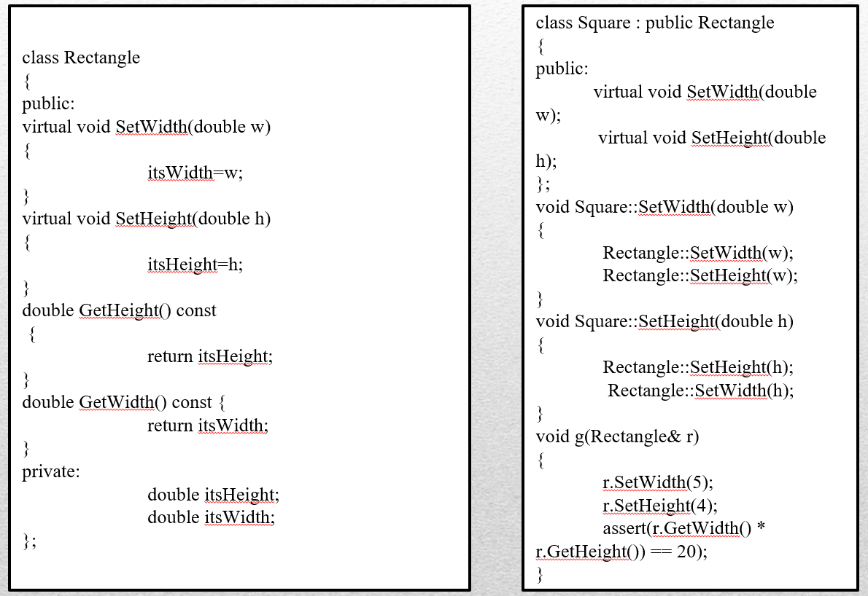

1. Consider the classes given above. Does this design maintain Liskov Substitution Principle (LSP)? Explain your answer.
2. How does the Open Close Principle (OCP) help in maintaining codebase? Explain with an example.

**QUESTION 2 (2+2=4 Marks)**

You have been assigned the job of engineering new word-processing software (similar to MSWord/ LibreOffice). A class named ***document*** is identified. Define the attributes and operations that you think are relevant for class ***document***.

**QUESTION 3 (2+2=4 Marks)**

Briefly describe where you would use the Strategy Design Pattern and the Template Method. Explain with a suitable example for each of the patterns.

**QUESTION 4 (3+1+3=7 Marks)**

Consider the following program:

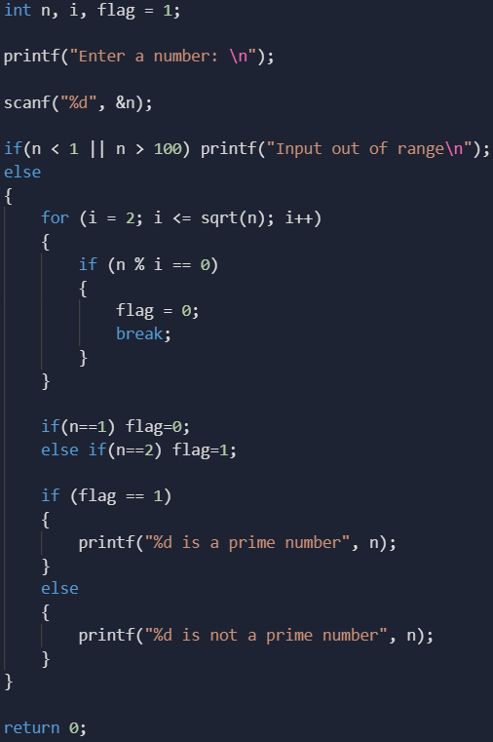

1. Draw the Control Flow Graph for the program
2. List all independent paths
3. Calculate the cyclomatic complexity of the program using all three methods.

**\*\*END OF QUESTIONS\*\***